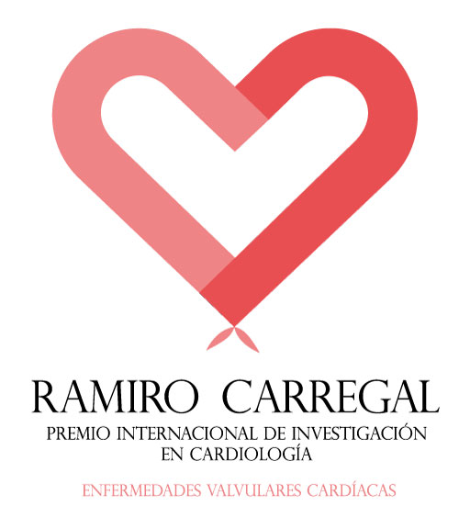

1st INTERNATIONAL AWARD FOR INVESTIGATION IN CARDIOLOGY “RAMIRO CARREGAL CARDIOVASCULAR ILLNESSES”

ANNEX 2: TEMPLATE FOR THE SUMMARIZED CV OF THE MAIN RESEARCHER AND THE PROJECT RESEARCH TEAM

TITLE:

MAIN RESEARCHER:

RESEARCH TEAM:

Section 1: PUBLICATIONS [Selection of 10 publications (original, editorial or revisions) from the last 5 years (2013-2017) in a SENIOR position, as first or last author]. The publications should be indexed in the JCR 2017. Each publication should include: Title, Authors (marking those authors in the Project research team in bold), Quartile and Decile.

Section 2: CLINICAL TRIALS OR STUDIES [List of clinical trials in which the candidate has appeared as the main researcher in the last 5 years (2014-2018)]. Each trial should include: Title, Main Researcher, Field and phase.

Section 3: INVESTIGATIVE PROJECTS [List of investigative projects that have been awarded funds through a competitive process, in which the candidate appears as the main researcher, including a member of the research team, in the last 5 years (2014-2018)]. Each project should include: Title, Main Researcher, Funding Body, Amount, Date of start and end.

Section 4: PATENTS [List of patents awarded or being exploited in which at least one member of the research team appears as author, in the last 5 years (2014-2018)]. Each patent should include: Title, Inventors and Current State.

Section 5: R & D CONTRACTS WITH INDUSTRY AND BUSINESSES [List of research contracts in the last 5 years (2014-2018)]. Each contract should include: Title, Entity, Amount, Date of start and end. IMPORTANT: Do not include clinical trials or observational studies in this section)

